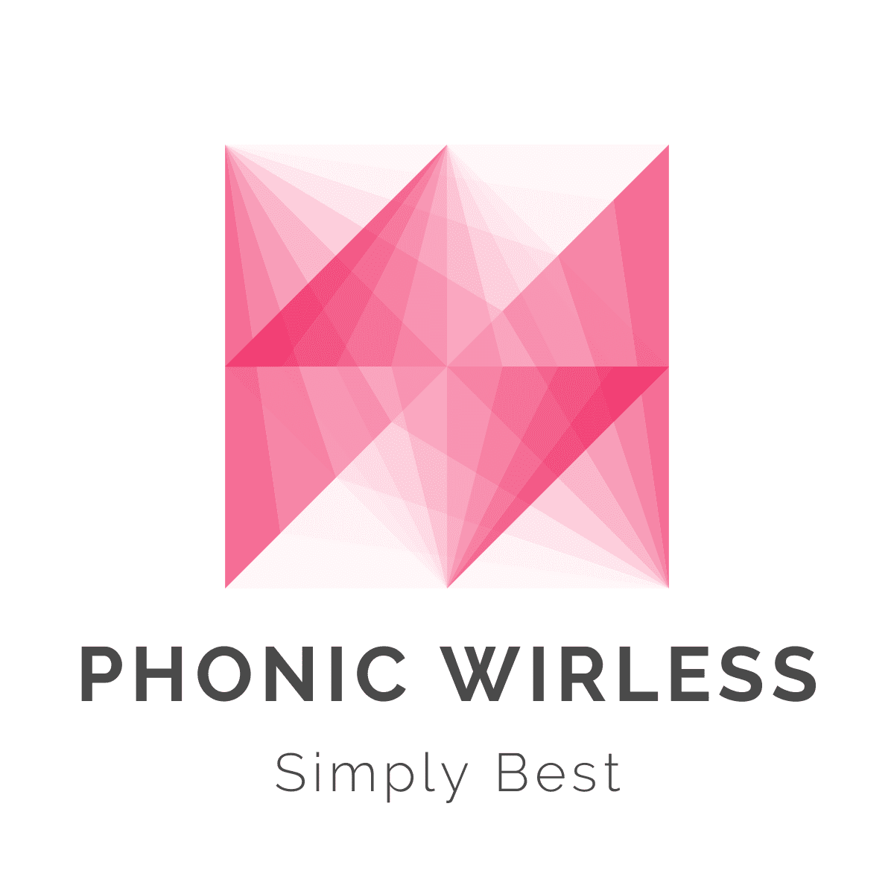

**ONLINE MOBILE RECHARGE**

**Submitted By**

**Sidra, Salim, Bibata**

**OBJECTIVE:**

Phonic Wireless is an Online Mobile Recharge web-based application developed to Recharge mobile phones online. This online mobile recharge system is beneficial to both the admins and users. This System will provide facility for Customer to Recharge mobile at anytime from anywhere. It makes easy for a Mobile recharge owner to manage records of various Plans.

**PURPOSE OF ONLINE RECHARGE SYSTEM**:

The purpose of the web application is the automation of mobile recharge. This website would help the customers to recharge their phones from anywhere and anytime online. Keep record of all the recharges. View transaction of the recharge. Application maintains the records of all the documents involved in various Recharges.

**USERS:**

Users can register to create an account based upon his/her user Id and Password. If authentication succeeds the user is marked as “logged in” and gets the privilege of inserting, deleting, retrieving or updating records. User can pay their phone bill using debit or credit card after entering their phone number. Data of all the recharges is stored in one centralized database. User can easily use this application without any technical knowledge. But user must have knowledge about the machine and application doesn’t need any professional to use the application. User can easily access the data, maintain the record of Recharge.

**ADMIN:**

Admin can add new plans, offers and update or modify the existing plans. In this system, there is a login process for the Admin. By default, all Admin features of the application are disabled. Admin needs to give valid user id and password. Once the Admin has logged in successfully, they can use the application. After login to the application the Admin can access the application, they can add and edit, the various information regarding the Recharges, View Past transactions

**BENEFITS OF ONLINE RECHARGE SYSTEM:**

Online Recharge system keeps record of all the recharges and purchase etc. User sees the details of recharges done in a day which reduces the chances of misplacing of details.

**MAIN FUNCTION OF MOBILE RECHARGE SYSTEM:**

* To keep record of all the recharges.
* To keep records of Sales and Purchase.
* To keep record of Plans.
* Faster processing of accessing the details.
* To help user for better management of Recharges.

**DESIGN OBJECTIVES:**

Software design is the first of three technical activities- design, code generation and test that is required to build and verify the software. Each activity transforms information in a manner that ultimately results in validated computer software.

**Practically:**

The proposed system must be quite stable and can be operated by the people with average intelligence.

**Efficiency:**

It tried to involve accuracy, timeless and comprehensiveness of the system output.

**Security:**

Proper authorization is done to take care of who is accessing the database and proper security measures are taken.

**Cost:**

It is desirable for the system with minimum cost subject to the condition that it must satisfy the entire requirement.

**TECHNOLOGIES USED:**

Notepad++

HTML, CSS, JavaScript, jQuery, Bootstrap

**HARDWARE REQUIREMENTS:**

* i3 Processor Based Computer or higher
* Memory: 1 GB RAM
* Hard Drive: 50 GB
* Monitor
* Internet Connection

**Problem Definition:**

* Takes lot of time
* In current system maintaining security is very difficult.
* There are calculation errors.
* In today’s world most of the people don’t have time to go to retail shops and do the recharge.
* Every time your talk time runs out, you have to rush to the vendor for buying recharge.
* Sometime while having an important talk/discussion with your friends/family/client, the talk time get over.

**Advantages of Proposed System:**

* This is useful for customer to recharge mobile from anywhere and anytime.
* Easy to get information as per requirement.
* More user friendly since it is an easy language.
* Maintain history of past as well as present recharges.
* Reduces paperwork.
* Very easy to maintain data and information about data.

**Navigation Structure:**

**ADMIN MODE:**

1. **Admin Login:**

It allows authenticated admin to enter the system.

1. **Add Plans and Offers:**

Allow admin to view various recharge plans & also allow admin to add new offers and plans.

1. **View Users:**

Allows Admin to view users and their account and contact information.

1. **View Transactions:**

View transactions done in past months.

1. **View Feedback:**

View Customers feedback on offers and their connection service.

1. **Logout:**

Allows Admin to logout from Admin Mode.

**USER MODE:**

1. **Registration:**

Allows User to register for an account using username and password.

1. **Recharge:**

Allows User to select plan with desired value and pay with Debit or Credit Card.

1. **My Account:**

Allows User to view their account information as phone number, Plan, Data and Email address.

1. **View Offer:**

Allows user to shop for new plans and phones and pay with debit or credit card.

1. **Contact:**

Allows user to contact admin about concern and issues with the recharge and plans or give feedback.

**Target Audience:**

The general public. Our target audience includes general public. Most working people are busy and hardly get time to go to shop and pay phone bill. Students, Young people who use smart phones its easier for them to recharge their phone online in their busy life. We would like the site to attract further people from different companies to choose our plan. An online competition platform would be ideal. We have been featured in a variety of local magazines and radio stations. We would like the website to attract further positive media attention and enable interested parties to download our press kits.

**DESIGN:**

**Screen shots of Project**

**MAIN PAGE:**

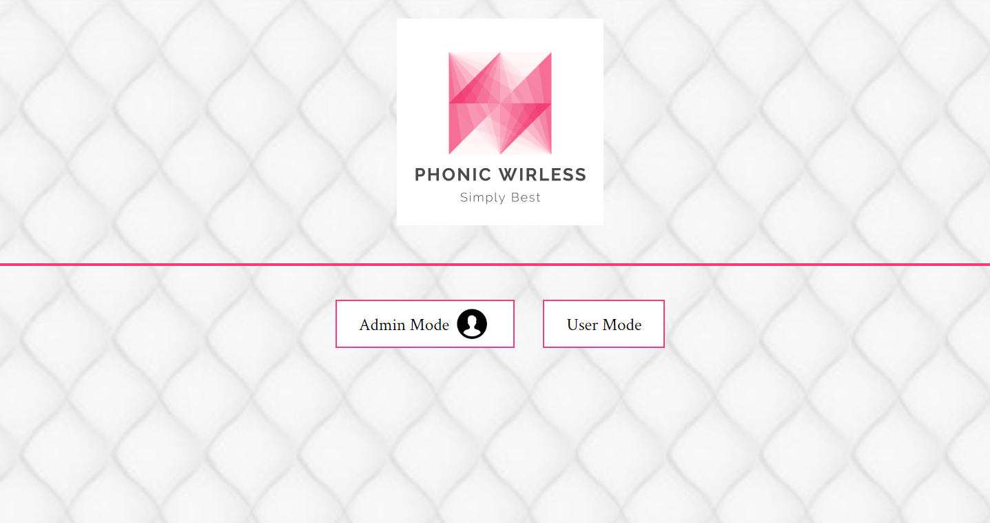[clip_image017](https://lh5.ggpht.com/-9_7lUcsC3KI/UzUAW8NIr5I/AAAAAAAAGE4/wNKRSbchWN0/s1600-h/clip_image017%255B8%255D.jpg)

**ADMIN LOGIN FORM:**

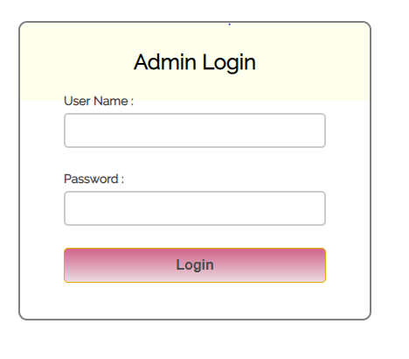

**ADMIN MODE:**

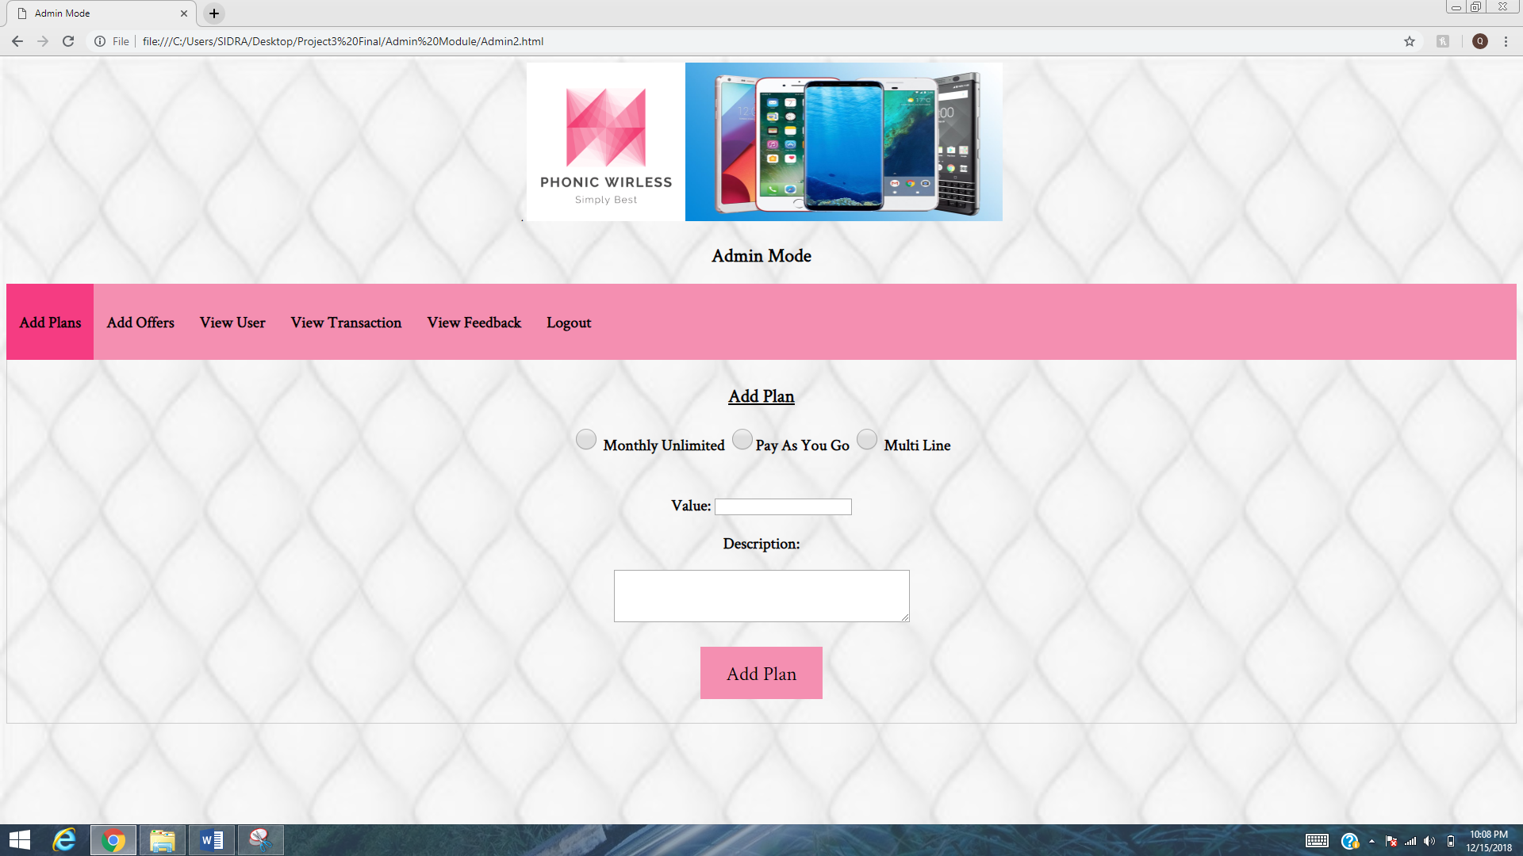

**VIEW TRANSACTIONS:**

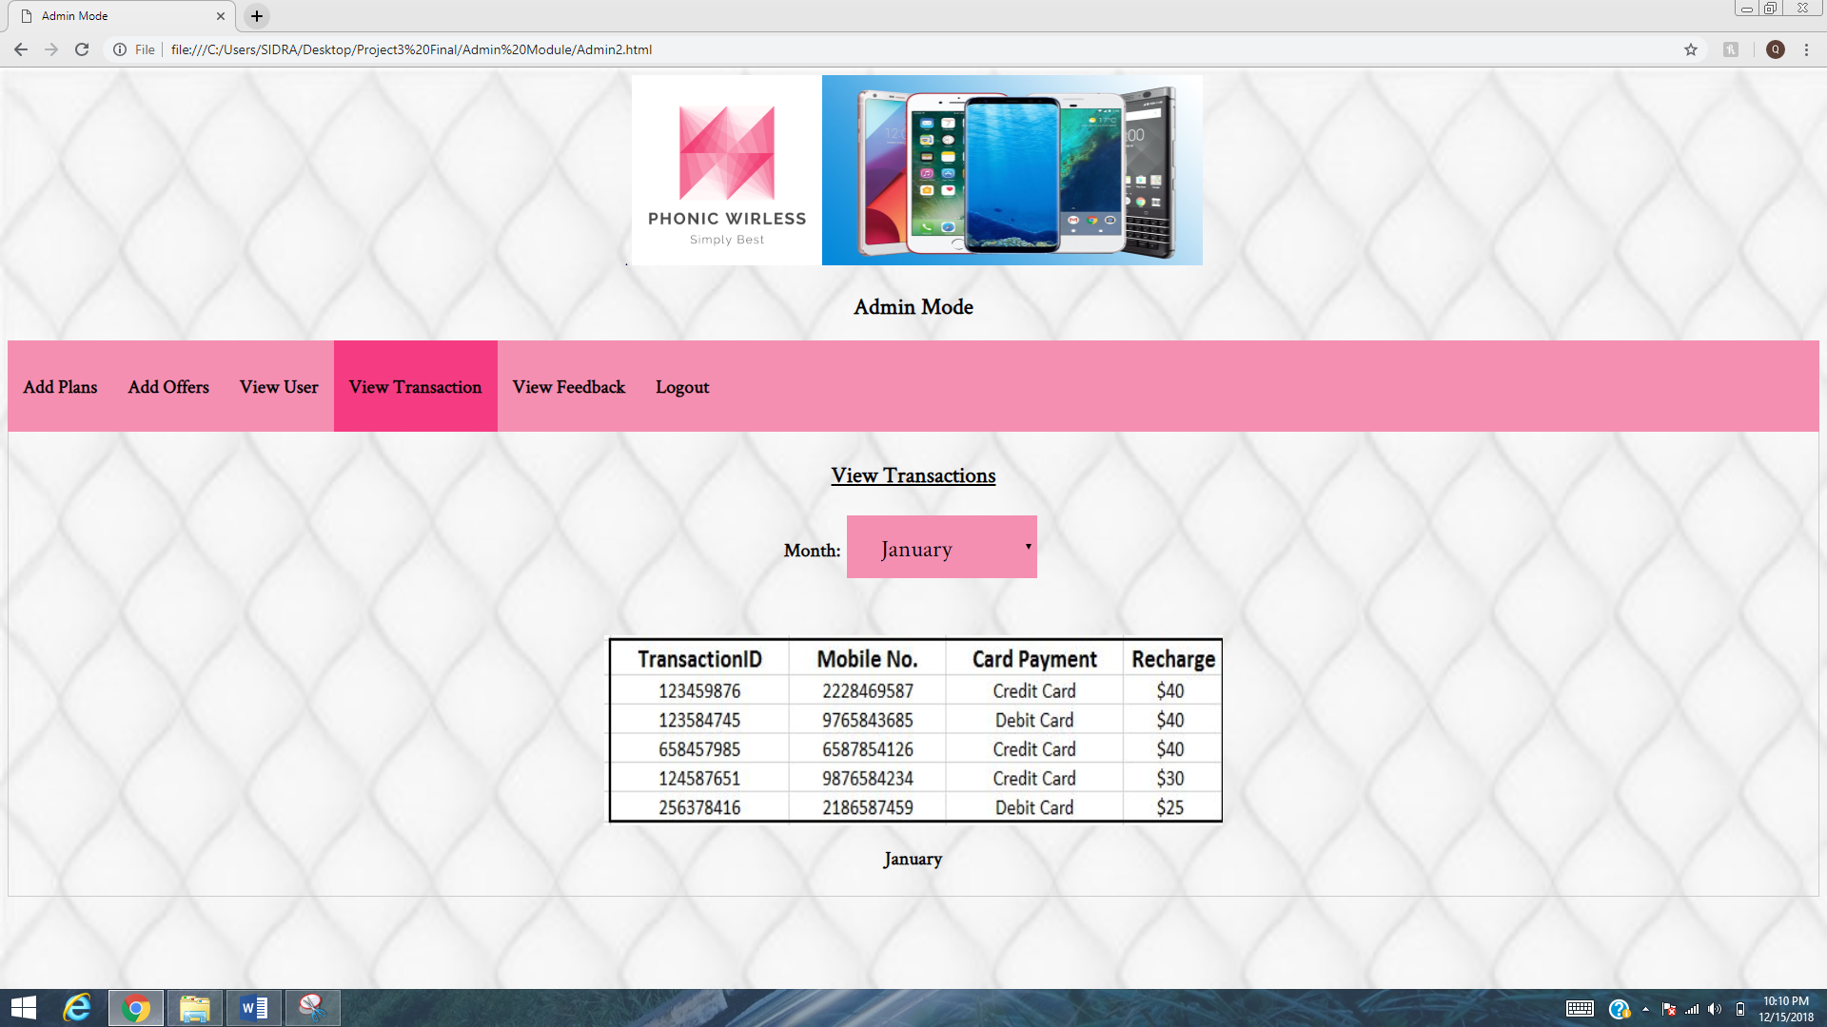

**USER MODE HOMEPAGE:**

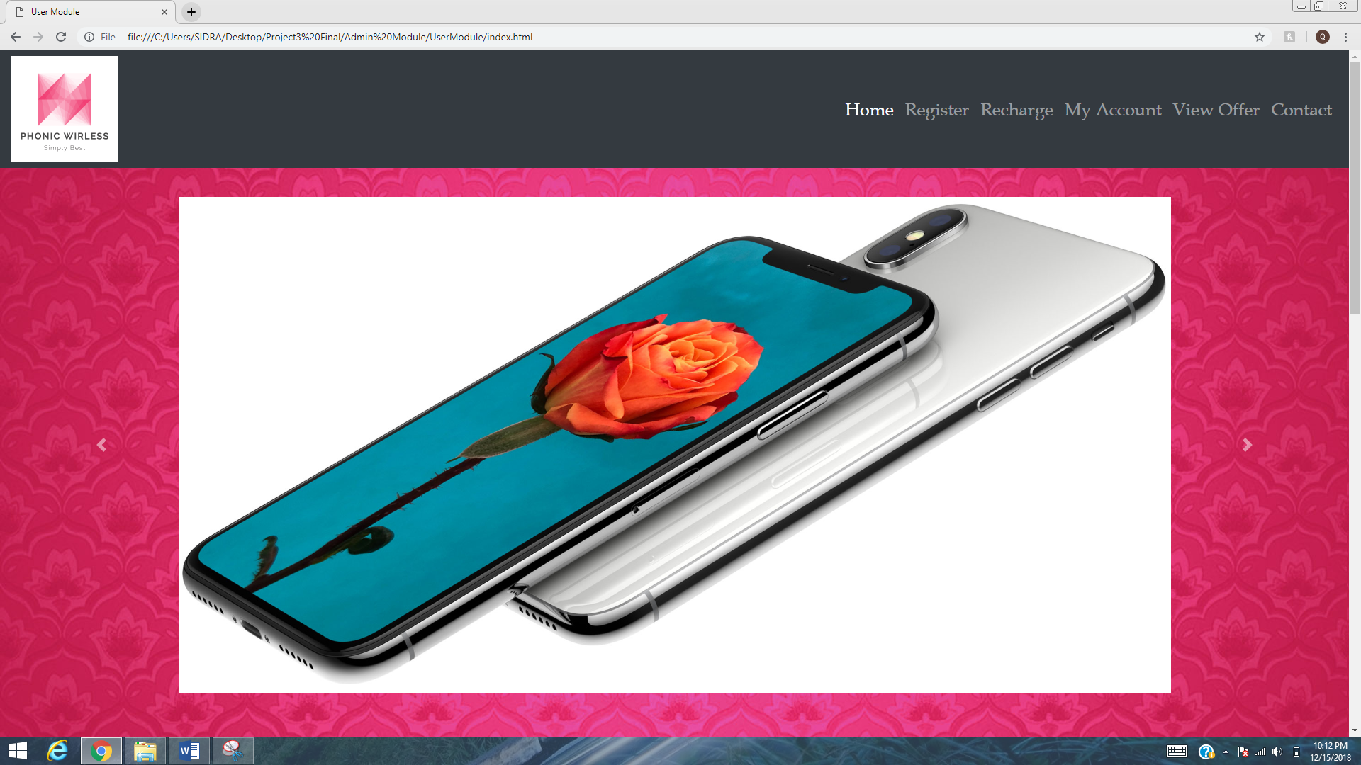

**RECHARGE FORM:**

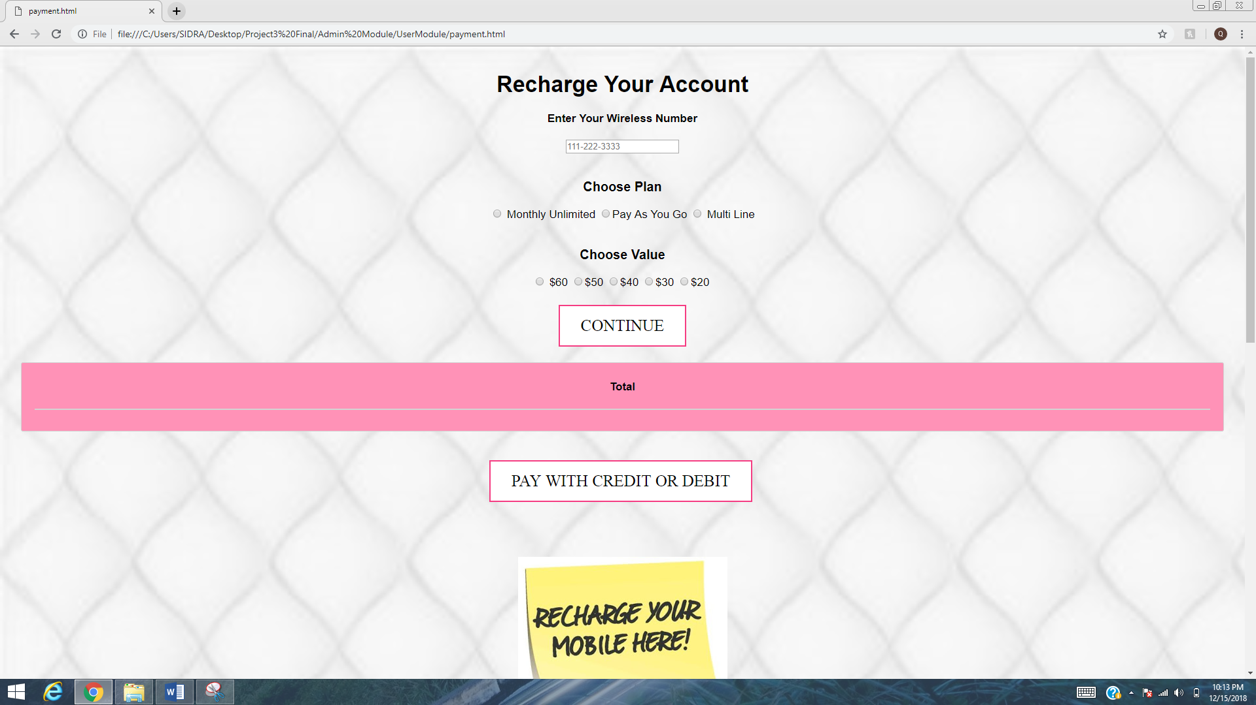

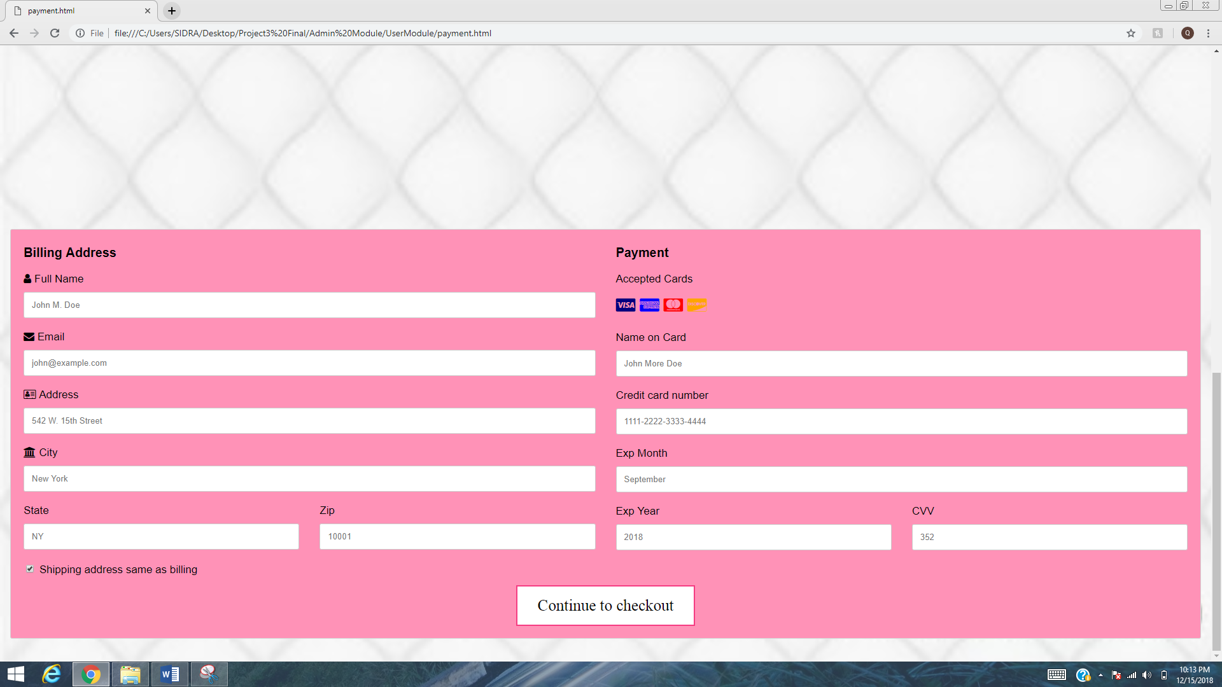

**ACCOUNT INFORMATION:**

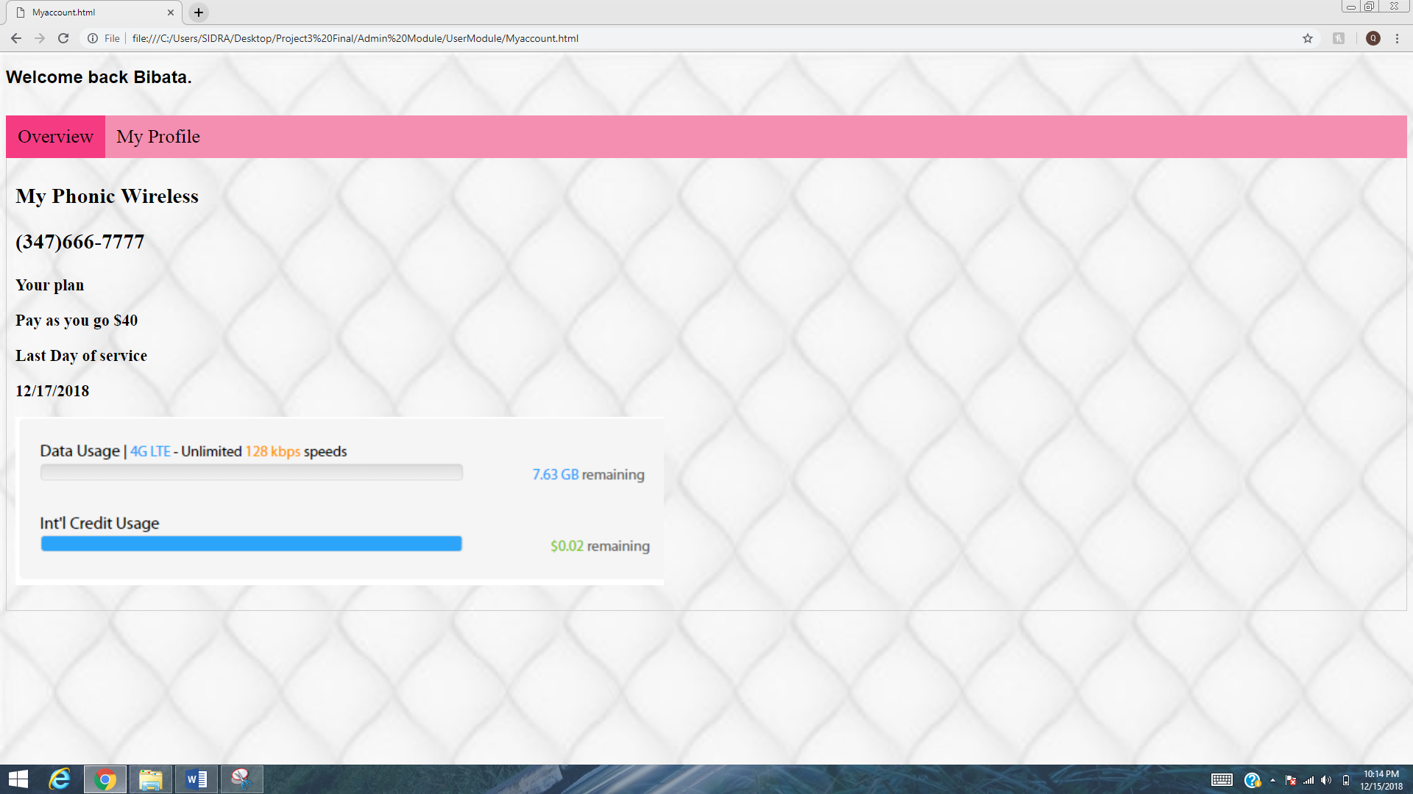

**VIEW OFFERS:**

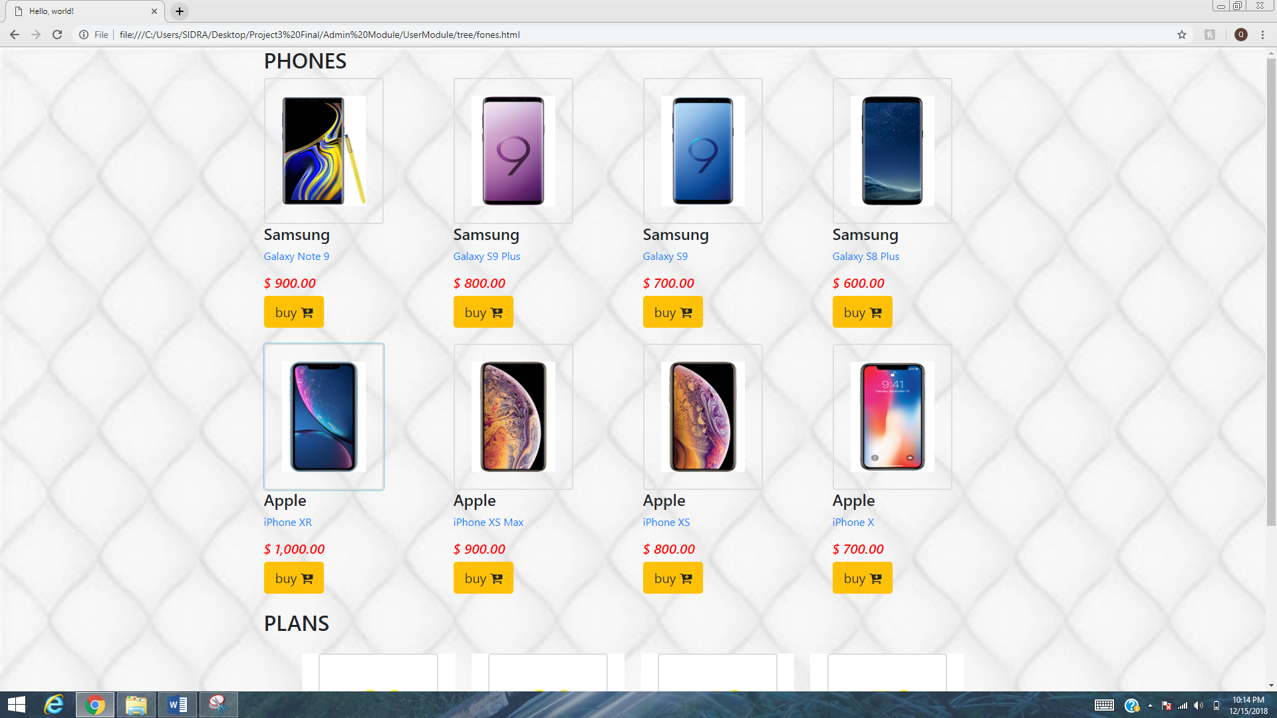

**CONTACT FORM:**

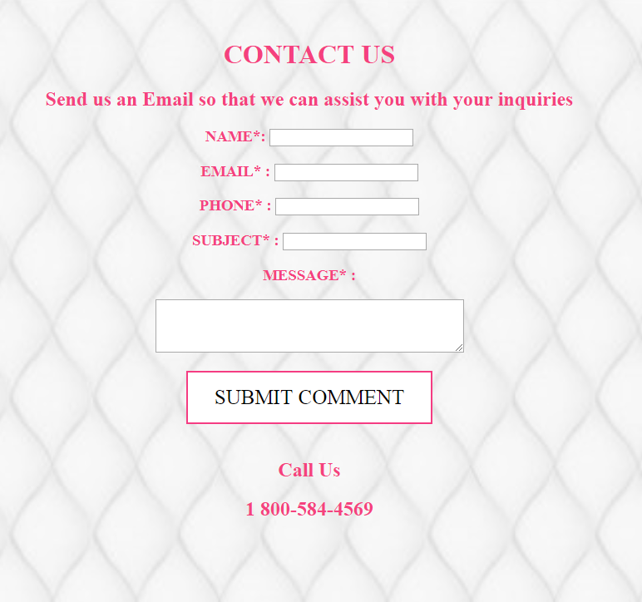

**8. CONCLUSION:**

The system has been developed for given condition and is found working effectively. The developed system is flexible, and changes whenever can be made easy. Using the facilities and functionalities of html and JavaScript the software has been developed in a neat and simple manner, thereby reducing the operators work.

The speed and accuracy are maintained in proper way. The user-friendly nature of this website is every easy to work with both for the higher management as well as other employees with little knowledge of computer. The results obtained were fully satisfactory from the user point of view.

This application is beneficial for the Mobile Companies and Distributors. It replaces paper- driven processes. It saves time as well keep the records safe. It helps in managing whole transaction of recharges including purchase and balance. It helps in keeping the record of recharges done on mobile number in particular month and year. By using this application user can keep the record of mobile recharges.

**9. BIBLIOGRAPHY & REFERENCES**

<https://www.w3schools.com/>

<https://getbootstrap.com/docs/4.0/components/carousel/>

<https://www.tutorialrepublic.com/>

[www.google.com/](http://www.google.com/) images